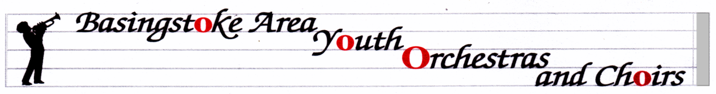

di.fuller@btinternet.com Sequoia House
Micheldever
01256 398211 Winchester
07799 691861 SO21 3BQ
www.bayo-hampshire.org.uk

BAYWO CHRISTMAS CONCERT

Sunday 10th December in Queen Mary’s College Hall

The concert starts at 7pm, so please arrive by 6.30pm
Admission for the audience will be by programme at the door, cost £5 (£3 concessions).
For audience members attending the afternoon concert as well, there will be a £1 discount for a combined ticket.
Full BAYO uniform please - black trousers or skirt, BAYO shirt (with red tie for boys). Boys’ shirts must be tucked in, with the top button fastened. Smart black shoes please - no trainers or flip-flops.
We expect players to stay and watch the 2nd half of the concert, as a matter of courtesy and support for the other groups.

The Friends of BAYOC would be grateful for any donations of shop-bought cakes or biscuits to sell at the refreshments table. Donations of quality raffle prizes would also be appreciated. It would be helpful if they are brought to a rehearsal before the day.

Saturday 3rd March 7.30pm The Anvil
Mayor’s Charity Concert
There will be a rehearsal in the afternoon. Time tbc.

Sunday 25th March 11.00am - 4pm Central Studio, QMC
Training day with Colin Touchin

Saturday 5th May 7pm The Anvil
BAYOC Evening of Youth Music
Rehearsal in the afternoon. Time tbc
Saturday, 30th June 7pm The Anvil - Wind Orchs from all of Hampshire
Rehearsal at 3.30pm Concert in the evening

Sunday 8th July BAYOC Summer Event
More details to follow
Please let us know immediately, in writing, if you are unable to attend any of these concerts. It is very important that we have a full turn-out.

There will be NO rehearsals on 12th or 19th Dec., and we will re-start on Tuesday, 9th January.

Di & John Fuller

