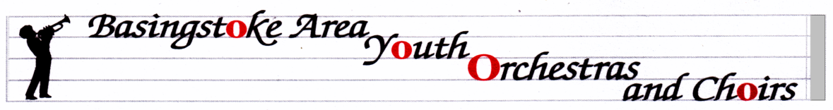

01256 398211 Sequoia House
07799 691861 Micheldever
Winchester
di.fuller@btinternet.com SO21 3BQ

Mayor’s Concert 3rd March - The Anvil

Everyone must arrive at the Anvil via the Stage Door and sign in.
Arrive at 1.00pm, and go to dressing rooms 4 & 5
Rehearsal from 1.15pm until 2.25pm

The concert begins at 7.30pm. Please arrive back at the Stage Door by 7pm, and go to the dressing rooms, tune and line up both sides of the stage when called.
BAYWO will remain on stage throughout the first half.

In the Interval, please put instruments away in cases, and players who are NOT in BAYO or BAYPE, or BAD, will be escorted to seats in the auditorium to watch the 2nd half. It is expected that everyone will stay for the whole concert.

Full BAYO uniform please.

Workshop Day with Colin Touchin - 25th March - Central Studio

The day will run from 11.15am until 3.30pm - please bring a packed lunch.

This will be a great opportunity for everyone to learn from Colin - a professional Conductor and Composer. Our previous days with him have been enjoyable, and the Orchestra has shown enormous improvement over the course of the day. We shall be working at some of the pieces we will perform in concerts over the rest of the year. Colin is coming to the UK from his home in Hong Kong, especially for us, so it is essential that we have full attendance please.
Any parents or other players who would like to come and observe some or all of the sessions will be most welcome.
Uniform is not required.

Advance Notice - BAYWO 25th Anniversary Reunion

On Sunday 16th September, we are having a special ‘Party’ and concert to celebrate 25 years since BAYWO began. This will be held at Thornden School, Chandler’s Ford, and we would like all current and as many ex-members as possible to be there.
There will be a rehearsal at 2pm, followed by light refreshments and an opportunity to chat and socialise, and we will conclude with a massed concert, hopefully with lot of past members coming back to play. There are details of this event on the website: bayo-hampshire.org.uk. This will be free of charge to participants, and is likely to run between 1.30pm and 7pm.

