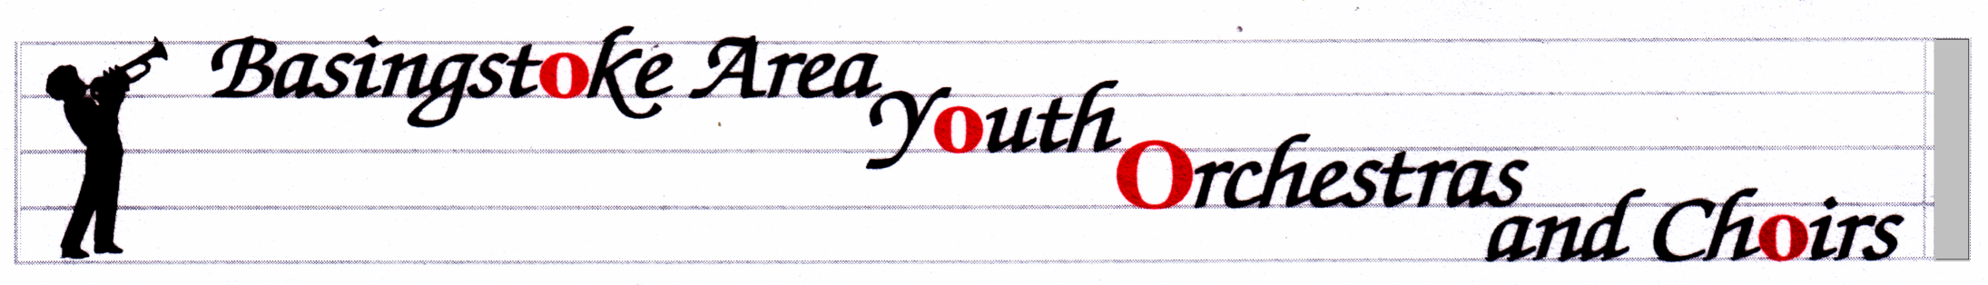
Sequoia House
Micheldever
Winchester
SO21 3BQ
01256 398211
11/11/16
johnfuller3@gmail.com

BAYO Rehearsals / Concerts

- Concert – Sunday, 4th December - in Queen Mary's Hall at QMC. The concert will start at 7pm - there will be a rehearsal at 5.30pm preceding the concert. Admission for the audience will be by programme at the door, cost £5 (£3 concessions). For audience members attending the afternoon concert as well, there will be a £1 discount for a combined ticket. BAYO, BAYWO, the Youth Choir, the Guitar Ensemble & the Percussion Ensemble will be taking part. Full BAYO uniform is required for this concert. Boys’ shirts must be tucked in, and with the top button fastened. Smart black shoes are required – no trainers or flip-flops.
- The Friends of BAYOC would be grateful for any donations of shop-bought biscuits and cakes to sell at the refreshment table, and quality raffle prizes, please. It would be helpful if they were brought to the rehearsal before the day.

- Rehearsals next term – Mondays 9th & 23rd January, 6th & 13th Feb, 27th Feb, 13th & 27th March, 3rd April. There are more rehearsals than usual because of the Mayor’s Charity concert in the Anvil on Saturday, 4th March. There will be a rehearsal that afternoon, the time is to be confirmed. The concert starts at 7.30pm.

- Rehearsals – Summer term - 24th April, 19th & 26th June, 3rd July – all at QMC as usual.

- Anvil concert - Sunday, 30th April - there will be rehearsal in the afternoon - time to be confirmed. The concert will start at 7pm.

- Summer concert - Sunday, 9th July – this will be at Queen Mary’s College at 7.00pm.

- It is very important that you let us know if you cannot attend any of these dates

John & Di Fuller

