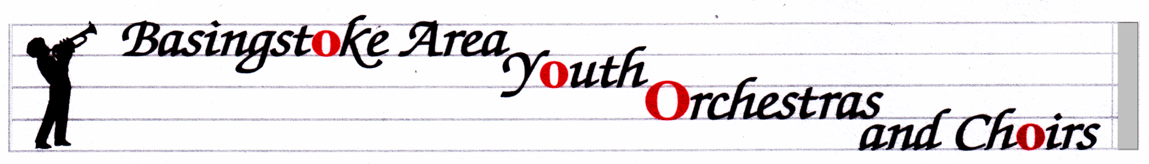
BASINGSTOKE AREA YOUTH WIND TRAINING ORCHESTRA
http://www.bayo-hampshire.org.uk/

27 September 2017
Dear Parents and musicians,

Welcome (back) to BAYWTO. It’s been a great start with lots of new players settling in well. Please note my email address at the bottom of the page, and try to use it from now on, although I still have my icloud address.

Our website above is a good way to make sure that you know what is going on with all the ensembles in the group, and with the Friends organization. My letters will always be on there in case you lose this emailed copy. If you would rather receive these letters on paper, please let me know. We have our AGM on Wednesday 18th October at 7pm. I have attached some information about it from the committee. Go to the Reception area at QMC and follow the signs. I hope you can make it.

Concerts this year:
Sunday 10th December probably starting at 2.30 at Queen Mary’s Hall (next to where we rehearse). I expect the concert to finish at about 4.30.
Saturday 24th February 2018 – Workshop Day - see below.
Saturday 5th May 2018 – Anvil Concert 7pm, with rehearsal during the day. I’m afraid this is the Bank Holiday weekend but we can’t always choose the dates, and at least we get an extra day off work/school.

Saturday 24th February (provisional date): At no cost to you whatsoever, we have a whole day planned, based at Great Binfields Primary School, designed to develop the players’ skills and experience, aiming for our performance at The Anvil in May. There will be a short performance at the end of the day. Please put it in your diary NOW and do your level best to be there. Only when we have everyone from the band together can we develop the overall sound of our ensemble.

Hire or Exchange Concert Uniform: Members of our ensembles are required to wear a uniform for performances. If you are new and haven’t already done so, please go to the website for information on how to buy into the uniform system: https://www.bayo-hampshire.org.uk/concert-uniform-information/. If you haven’t tried your shirt on for some time, please do so…..now.

Trinity Graded Challenge: following the success of the Sponsored Grade 1 Challenge last February, we are repeating it next year, but it is now open to any grades. Flyers will be coming out at the next rehearsal; alternatively there is information on the website. I gained my Grade 1 cello and am looking to take either my Grade 3 or Grade 4 this time round.
NO rehearsals on Tuesday 12th or 19th December.
Mrs. Serena Ludford serena.ludford@hms.hants.gov.uk 07796 694049
12 Oakley Lane, Oakley, Basingstoke, RG23 7JZ

