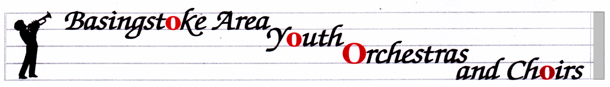
BASINGSTOKE AREA YOUTH WIND TRAINING ORCHESTRA
http://www.bayo-hampshire.org.uk/

03 November 2016
Dear Parents and musicians,

Our website above is a good way to make sure that you know what is going on with all the ensembles in the group, and with the Friends organization. My letters will always be on there in case you lose this emailed copy.

Concerts this year:
Sunday 4th December 2.30 at Queen Mary’s Hall (next to where we rehearse). Please arrive in time to leave your instrument backstage and join the audience, as we are performing in the 2nd half. I expect the concert to finish at about 4.30. This is also an opportunity to hear some of the other groups in BAYOC. We are, as ever, looking for raffle prize donations as well as donations of shop-bought mince pies/biscuits/mini cakes. If you would be willing to provide these, please bring them to a rehearsal in December.

Saturday 4th February: At no cost to you whatsoever, we have a whole day planned, based at Great Binfields Primary School, designed to develop the players’ skills and experience, aiming for our performance at The Anvil at the end of April. There will be a guest conductor in the afternoon, and a short performance at the end of the day. Please put it in your diary NOW and do your level best to be there. Only when we have everyone from the band there can we develop the overall sound of our ensemble. The day will run from 9.30 to 4.00 and I will get a letter out about it before Christmas.

SUNDAY 30th APRIL 2017 – Anvil Concert 7pm, with rehearsal during the day (it is often 11.30-12.30 but that has not been organized fully yet). I’m afraid this is the Bank Holiday weekend but we can’t always choose the dates, and at least we get the following day off work/school.

Sunday 9th July 2017 – Summer Event at QMC.

Hire or Exchange Concert Uniform.

Members of our ensembles are required to wear a uniform for performances. If you are new and haven’t already done so, please go to the website for information on how to buy into the uniform system. If you haven’t tried your shirt on for some time, please do so…..now. The system we run means that the shirts can be exchanged for larger sizes at no extra cost. Just bring them in to me at a rehearsal, with a note requesting the new size and I can sort the rest.
NO rehearsals on Tuesday 6th or 13th December. We restart rehearsals on Tuesday 10th January 2017.
Mrs. Serena Ludford serena.ludford@hms.hants.gov.uk 07796 694049
12 Oakley Lane, Oakley, Basingstoke, RG23 7JZ

