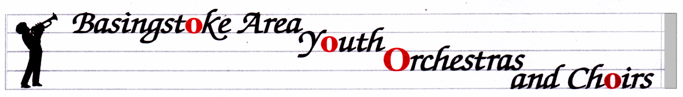
BASINGSTOKE AREA YOUTH WIND TRAINING ORCHESTRA
http://www.bayo-hampshire.org.uk/

25 September 2016
Dear Parents and musicians,

Welcome to BAYWTO. It’s been a great start with 20 new players settling in well. Please note my email address at the bottom of the page, and try to use it from now on, although I still have my icloud address.

Our website above is a good way to make sure that you know what is going on with all the ensembles in the group, and with the Friends organization. My letters will always be on there in case you lose this emailed copy. If you would rather receive these letters on paper, please let me know. We have our AGM on Tuesday 18th October at 8pm. I have attached some information about it from the committee. Go to the Reception area at QMC and follow the signs. I hope you can make it.

Concerts this year:
Sunday 4th December 2.30 at Queen Mary’s Hall (next to where we rehearse). I expect the concert to finish at about 4.30.
Saturday 4th February 2017 – see below.
SUNDAY 30th APRIL 2017 – Anvil Concert 7pm, with rehearsal during the day. I’m afraid this is the Bank Holiday weekend but we can’t always choose the dates, and at least we get the following day off work/school.
Sunday 9th July 2017 – Summer Event at QMC.

Saturday 4th February: For some years we have been away at Fairthorne Manor for a weekend in February, as many of you know. I have enjoyed this chance to get to know some of the players better, they have had a chance to make new friends, and the music has developed enormously at the rehearsals. However, I know that some have not been able to go away for a whole weekend for various reasons, so we are repeating the one-day workshop we did last year. At no cost to you whatsoever, we have a whole day planned, based at Great Binfields Primary School, designed to develop the players’ skills and experience, aiming for our performance at The Anvil at the end of April. There will be a guest conductor in the afternoon, and a short performance at the end of the day. Please put it in your diary NOW and do your level best to be there. Only when we have everyone from the band there can we develop the overall sound of our ensemble.

Hire or Exchange Concert Uniform.

Members of our ensembles are required to wear a uniform for performances. If you are new and haven’t already done so, please go to the website for information on how to buy into the uniform system. If you haven’t tried your shirt on for some time, please do so…..now.
NO rehearsals on Tuesday 6th or 13th December.
Mrs. Serena Ludford serena.ludford@hms.hants.gov.uk 07796 694049
12 Oakley Lane, Oakley, Basingstoke, RG23 7JZ

